**Augmented Reality- Is It the future...?**

**What is Augmented Reality?**

Augmented reality as said by (Margaret, 2015) “the integration of digital information with the user’s environment in real time.” Augmented reality is aiding our technologically advanced world a lot by providing many new ways of advertising products, making games, providing information and aiding students in studies. In this report, we will explore the future of augmented reality.

**What is the future of augmented reality?**

Augmented reality has provided many helpful features since its release in the early 90’s and in recent times, AR has proven to be superior to VR. From the release of the famous game, Pokémon GO to the famous educational study app Blippar. AR is said to grow rapidly over the next couple of years.

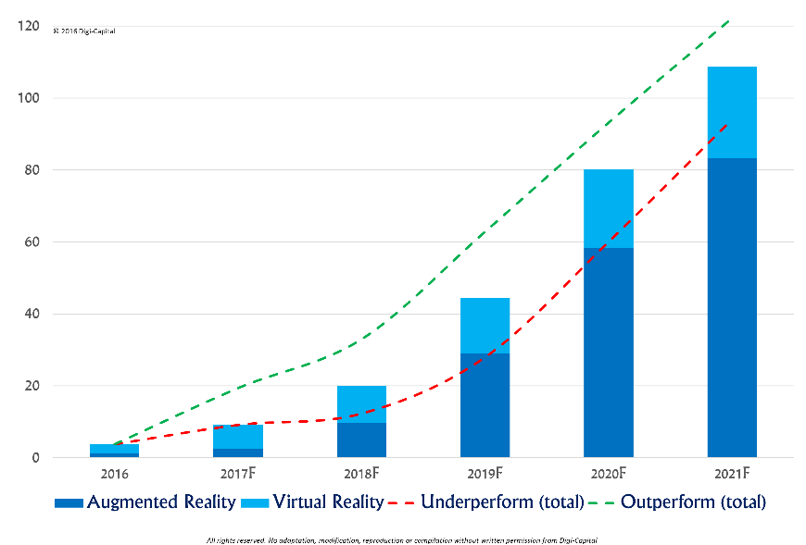 “By 2025, the AR and virtual reality space in the healthcare industry is predicted to reach $5.1 billion, engineering $4.7 billion, real estate $2.6 billion and retail $1.6 billion.” (Leadem, 2018).

Figure 1: VR/AR Revenue

As shown by figure 1 AR is predicted to gain a lot of revenue by 2021 with companies such as:

* Ikea
* Facebook
* Amazon
* Microsoft
* Google

Investing in AR as a mean of advertising and offer extra functionalities to its user’s.

Consoles such as the PlayStation and Xbox have already delved deep into the world of AR by integrating games with AR capabilities and creating unique things to be used by its respective audience.

AR has shown a potential of growth in its recent year as many companies have incorporated AR into their personal applications such as Ikea with its app ‘Ikea Place’ which enables its users to design their rooms with items from the Ikea catalogue before going to the shops to buy. With AR steadily growing it has been told to be the next technological leap forward with it already being used in glasses (Google Glasses), cars and social media platforms.

**Conclusion**

Before AR can get widely accepted it still has many flaws and many challenges to face as many people are not yet ready to accept this technology as an important part of our daily life.

With advancements and improvements to technology being made every day we cannot foresee where this technology will go as it has an unlimited room of improvement with numerous uses in various fields but as of now we are limited by our technology to further make improvements but sooner or later the technology to work alongside with AR will finally be there and AR might just become an integral part of our daily lives.

# References

Leadem, R., 2018. *The Future of Augmented Reality (Infographic).* [Online]   
Available at: https://www.entrepreneur.com/article/312271  
[Accessed 22 April 2018].

Margaret, R., 2015. *Augmented Reality.* [Online]   
Available at: https://whatis.techtarget.com/definition/augmented-reality-AR  
[Accessed 1 October 2018].

Merel, T., 2016. *The reality of VR/AR growth.* [Online]   
Available at: https://techcrunch.com/2017/01/11/the-reality-of-vrar-growth/  
[Accessed 1 October 2018].